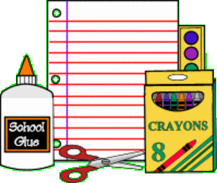
Second Grade Supply List
Please Note: No parents are permitted to escort students into the building with supplies or leave supplies at security to be delivered to classrooms. Only send in what your child can carry.

Please label all supplies with first/last name and class number!
Day 1: Please bring in the following supplies to school on Monday, September 13th. | Day 2: Please bring in the following supplies to school on Tuesday, September 14th.
- 6 WIDE rule lined composition notebooks – NO SPIRALS  - Please put your child’s first and last name on the front of each notebook!  - 6 folders (plastic preferred) One of each of the following colors: red, blue, yellow, orange, green, purple  - 2 boxes of # 2 pencils (recommended brand – Ticonderoga)  - 2 boxes of 24 count crayons (Crayola brand)  - 2 boxes of tissues  - 1 package of thick Expo Dry Erase Markers OR  - 1 package of “skinny” Expo Dry Erase Markers | - 1 pair of scissors (metal - with a point preferred)  - 2 packages of bar erasers  - 1 pencil case (recommended – hard box)  - 4 JUMBO glue sticks  - 1 box of GALLON zipper seal plastic freezer bags – Ziploc or Glad brand OR  - 1 box of QUART zipper seal plastic freezer bags – Ziploc or Glad brand  - 1 box of SANDWICH sized zipper seal plastic bags – Ziploc or Glad brand  - 1 ruler with inches and centimeters  - 1 package of 4 x 6 index cards  - 1 pack of colored pencils (Crayola brand)

